SOFTWARE REQUIREMENT SPECIFICATIONS (SRS)
FOR

REVAMPING THE BI DASHBOARD WEB APPLICATION DESIGN & DEVELOPMENT
SUBMITTED TO
IVTECH COMPUTER SYSTEMS LLC

Version: 1.0

22nd NOVEMBER 2024

Prepared By:
SPEC INDIA
Revision History

Date | Version | Author | Created / Updated / Reviewed / Verified / Approved By
10-03-2025 | 1.0 | Parth Jotangiya | Initial Draft
00-00-2025 | 1.0 | Yaman Kavishwar

Table of Contents
Contents
1. Introduction 4
1.1. Project Scope and Objectives 4
1.2. Items outside the Project Scope 7
1.3. Project Deliverables 7
1.4. Project Approach 7
1.5. Security, Best Practices & Supported versions 8
1.6. Assumptions, Dependencies and Constraints 8
1.7. System Architecture 9
2. Admin Application 11
2.1 User Management 11
2.2 Role Management 12
2.3 Role Assignments to The Admin User 12
2.4 Role Wise Permissions Management 13
2.5 Login Page for Admin User 15
2.6 Forgot Password Page for Admin User 16
2.7 Menu Items for Admin User 17
2.8 My Profile Page for Admin User 17
2.9 Change Password Page for Admin User 18
2.10 Dashboard Page for Admin User 19
2.11 Customer & Licenses Management 20

Introduction

Project Scope and Objectives

- The purpose of this project is to revamp an existing web application by developing a dashboard that enables surveillance professionals to make data-driven decisions. This includes enhancing the current application and implementing new features and functionalities as specified by the client.

- This document outlines the requirements for web applications to be developed for HANWHA VISION, a company internally associated with IVTECH COMPUTER SYSTEMS LLC.

- This requirement includes two types of applications which are enlisted below:

- Admin (License Dashboard) Web Application: This web application is designed for Hanwha Vision administrators to manage customers and their license details effectively.
- Client Web Application: This application is tailored for Hanwha Vision's customers. It will be web-based and accessible exclusively through web browsers. Additionally, it will provide the capability to be installed on a customer’s local machine via a single executable file (e.g.: .exe / .msi)

- The .exe or .msi file will handle the automatic installation of all necessary files, configurations, and dependencies on the customer's local machine. Once installed, the Client Web Application will be executed through the customer's web browser, operating within their local environment only.

- Camera APIs will be provided by Hanwha Vision or IVTech. SPEC INDIA will utilize these APIs for further development activities as outlined in this document. These activities will constitute the final scope of the project's requirements.

- The Requirement is present in the “Technical Requirements Doc R2” document shared by IVTECH COMPUTER SYSTEMS LLC, which contains information for Custom Web Application modules related to the following:
- User Login:
  - Users can log in using their credentials.
  - Users can reset their own password (Forgot password).
  - Change Password.
- User Management:
  - Add/Update/Delete users.
  - Assign Role - Permissions to Users to access camera/floor/zone/reports.
- Camera Management:
  - Add/Update/Delete camera.
  - Listing of Cameras with search/filter.
- Settings:
  - Upload Customer Logo.
  - License Management.
- Site and Zone Management:
  - Add/Update/Delete Site.
  - Add/Update/Delete Floor Plan.
  - Add/Update/Delete Zone on Floor Plan.
  - Add cameras to zones.
  - Camera rotation.
  - Map integration with static map images.
    - Imp Note:
      - For the Map Integration, the user needs to be online once, maybe while creating the Site to download the map images. Otherwise, we cannot identify which country/region/area images need to be downloaded to make the map work with static images.
      - For now, we will go for Open source to achieve the functionality of Offline maps. This is the subject of exclusive R&D; hence the final selection of the open-source solution will be done post R&D and discussion with the client team.
- Dashboard:
  - Report Filtering
  - Export to PDF/excel/csv.
  - Camera – No. of Camera Installed
  - Camera – No. of Camera Online/Offline
  - Camera - Online vs Offline Ratio
  - Camera – No. of Camera by Model Type
  - Camera – No. of Camera by Feature type
  - Site - Total Capacity
  - Site - Capacity Utilization (%)
  - Site - Most vs. Least Day for Capacity Utilization
  - Site - Zone-wise details for Max Capacity, Utilization, % (Table)
  - People Counting - People In
  - People Counting - People Out
  - People Counting - Avg. People In/Out in Day with Min and Max Count
  - People Counting - Cumulative People Count for Time
  - People Counting - Zone wise.
  - People Counting - Gender-wise.
  - People Counting - People with and without Mask/Helmet
  - People Counting - Most and Least Count Day for Specific Male and Female
  - People Counting - Slip and Fall Count for People with Gender
  - People Counting - New vs Total Visitors
  - Retail & Business AI Pack - Shopping Cart Counting
  - Retail & Business AI Pack - Heatmap for shopping cart
  - Retail & Business AI Pack - Queue events for shopping cart
  - Retail & Business AI Pack - Queue events for people
  - Retail & Business AI Pack - Blocked exit detection
  - Vehicle (Traffic (ITS) AI pack) - Vehicle Count (Min, Max, Avg. per Day)
  - Vehicle (Traffic (ITS) AI pack) - Vehicle by Type
  - Vehicle (Traffic (ITS) AI pack) - Vehicle In/Out
  - Vehicle (Traffic (ITS) AI pack) - Vehicle in Wrong Direction
  - Vehicle (Traffic (ITS) AI pack) - Stopped Vehicle Count Time
  - Vehicle (Traffic (ITS) AI pack) - Speed Detection by Vehicle
  - Vehicle (Traffic (ITS) AI pack) - Avg. Speed for Vehicle
  - Vehicle (Traffic (ITS) AI pack) - Traffic Jam by Day
  - Vehicle (Traffic (ITS) AI pack) - Day-wise Traffic (Most and Least)
  - Vehicle (Traffic (ITS) AI pack) - Speed Violation by Vehicle
  - Vehicle - Vehicle U Turn detection
  - Vehicle (Traffic (ITS) AI pack) - Pedestrian detection
  - Vehicle (Traffic (ITS) AI pack) - Vehicle Turning Movement counts
  - Vehicle (Traffic (ITS) AI pack) - Vehicle Queue Analysis
  - Vehicle (Traffic (ITS) AI pack) - Vehicle Detection Heatmap
  - Factory & Safety AI pack - Detect Forklifts
  - Factory & Safety AI pack - Proximity detection (between people, forklifts, between a person and a forklift)
  - Factory & Safety AI pack - Forklift speed detection
  - Factory & Safety AI pack - Counting & Heatmap for forklift and people
  - Factory & Safety AI pack - Queue events for forklift and people
  - Factory & Safety AI pack - Blocked exit detection
- The list of dashboard widgets specified above includes existing APIs related to Crowd Management, Queue Management, Traffic (Vehicle), Retail, and Factory AI Pack. Which will be provided by the client only.
- Package creation:
  - Create a package to install the web application on Windows PC only.
- Data Ingestion:
  - Scheduled calling of Camera APIs to ingest data in the database.
- Camera API Understanding and Integration:
  - Details of the Solar Power and Battery Utilization will be shown on the dashboard through SNMP/API integration with the BMS and MPTT Controller (calling of camera API and just displaying the data available from API).
- Configuration:
  - Standard Backup and Restore.
- AI Box Integration:
  - AI Box integration, considering the addition of multiple cameras in a single AI Box and considering the cameras added in the AI Box to display Dashboard widgets data.
- Alexa Integration:
  - Integration with Alexa, so that when the Alexa device is connected, it will open the specific widget on voice command.
- 7 other key features:
  - Provide data for multiple lanes (8 lanes).
  - Show heat maps on the floor plans and particular zones.
  - Multisite-wise dashboard widget reports.
  - For Multisite should be filtered to select the widgets and show the difference between Full site, single-zone, and Multizone.
  - SSL / HTTPS set up, (The SSL certificate will be purchased by client only).
  - Need to have Event reporting details with filtration with separate widgets or separate pages for this, and when the event is reported, need to have pre- and post-video of 5 seconds each.
  - SMTP server setup for email reporting with scheduled job (Required credentials will be provided by client only).
- Admin (License Dashboard) Application:
  - Admin users can log in using their credentials.
  - User Management
  - Customer Details
  - Customer Licensing details, generating licenses, and sending emails to respective addresses.

- The technology used to develop web applications will be:
Front-end: React.js
Back-end: .NET Core + Web API (C#)
Database: MongoDB

Items outside the Project Scope

- Creation of APIs which will be directly interacted with AI camera configured by Hanwha. SPEC INDIA will only utilize camera APIs managed by Hanwha and will replicate/ingest the necessary information in the database (if required) & display that required information on the web application.

- Multilingual support for web application. Application will be only in English language.

- Responsiveness to Tablet & Mobile. Application will be supported to desktop computer screen only.

- The development of Mobile Application for Android and iOS native integration will be out of scope.

- QA Testing is out of scope because client team will do it from their end.

- Failover plan for the database in case of any future failures.

Project Deliverables

- SPEC INDIA will be delivering below items as part of project deliverables:
  - System Requirements Specification (SRS) Document.
  - Source Code files.

Project Approach

- The proposed approach for the execution of this project is the Waterfall approach, where requirements will be gathered, analyzed, and baselined to form the scope of the system.

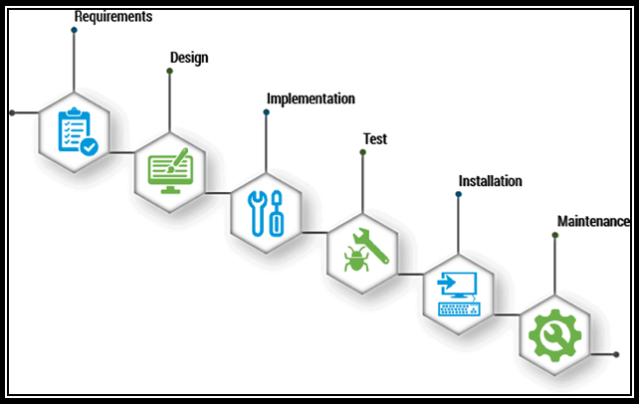

Security, Best Practices & Supported versions
  - Application will be protected by cyber security and vulnerability.
  - The Web Application for Client & Hanwha Admin will work on desktop and laptop screens; it is not mobile & tablet responsive. It will work on the latest versions of Google Chrome, Mozilla Firefox & Microsoft Edge.
  - The browser version at the time of UAT release will be considered as the latest support version.

Assumptions, Dependencies and Constraints
  - Any type of Server hosting fees, license cost, any other 3rd party API/SDK fees are not part of
development cost and will be procured and paid by client.
  - SPEC will have no liability for hardware failure deployed when running the proposed solution. Hence, the client should only take up relevant issues with the provider for the respective system.
  - Designs showcased in this SRS document as well as the ones shown to the client during the project query discussion calls will be considered as the final designs.
  - SPEC INDIA will not be responsible for any sort of server setup on the client’s UAT or Production Environment.
  - Database administration activities will not fall under the responsibility of SPEC INDIA team.
  - Once the application is live in Production, the database maintenance plan must be configured from the client’s end.
  - SPEC INDIA will not be responsible for any Point-in-Time Database Recovery/DR Drill/Database Upgrade/ Maintenance tasks etc.
  - The details are prepared based on the client's discussion; hence, changes may be made after completing the requirements study, which may require discussions under the change management process.
  - Any delay in the project schedule due to decision-making, data gathering, or approvals from the client side should be handled at the client's side. SPEC INDIA won’t be responsible for adding more resources for early completion in such scenarios.
  - The warranty period will automatically start ten days after the UAT rollout & the warranty period will be 3 months.
  - After warranty completion, extra charges will be charged for knowledge transfer or documentation for/to another vendor.
  - The client will own the developed product and source code submitted after the final milestone payment.
  - A delay during any phase of the project by the customer will not be considered a delay by SPEC INDIA, and any payment milestone will not be delayed due to it.
  - Any delay in providing feedback or required dependency for more than two weeks will be escalated by SPEC INDIA.

System Architecture

- The image below represents the flow of the entire system architecture & it concludes all the applications like Admin, Client as well as backend middleware for both the applications:

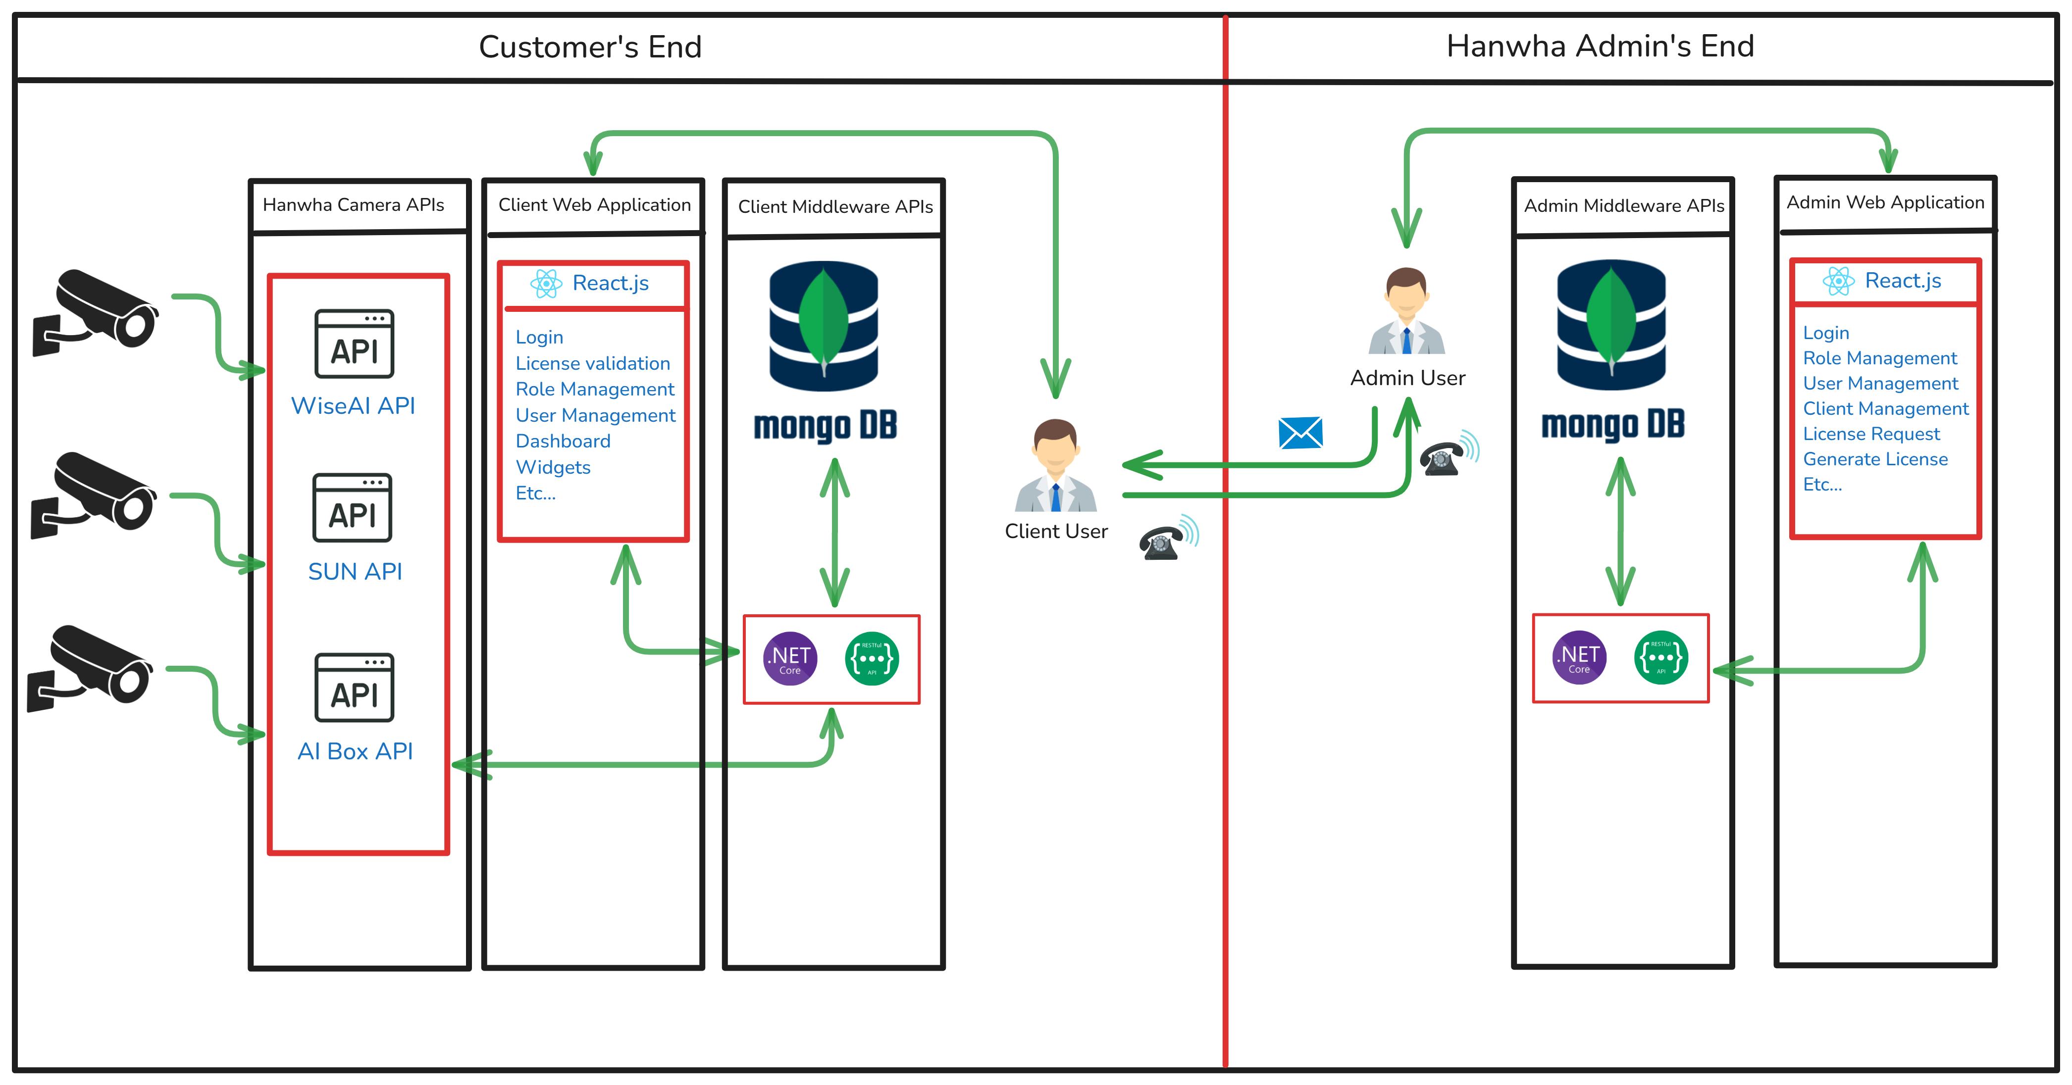

- The architecture below represents the flow of backend development using .NET Core + Web API:

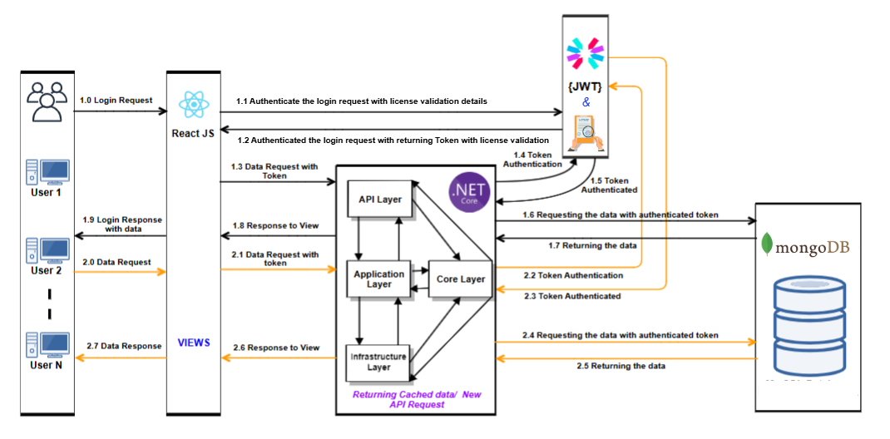

- The architecture below represents the flow of frontend development using React.js technology:

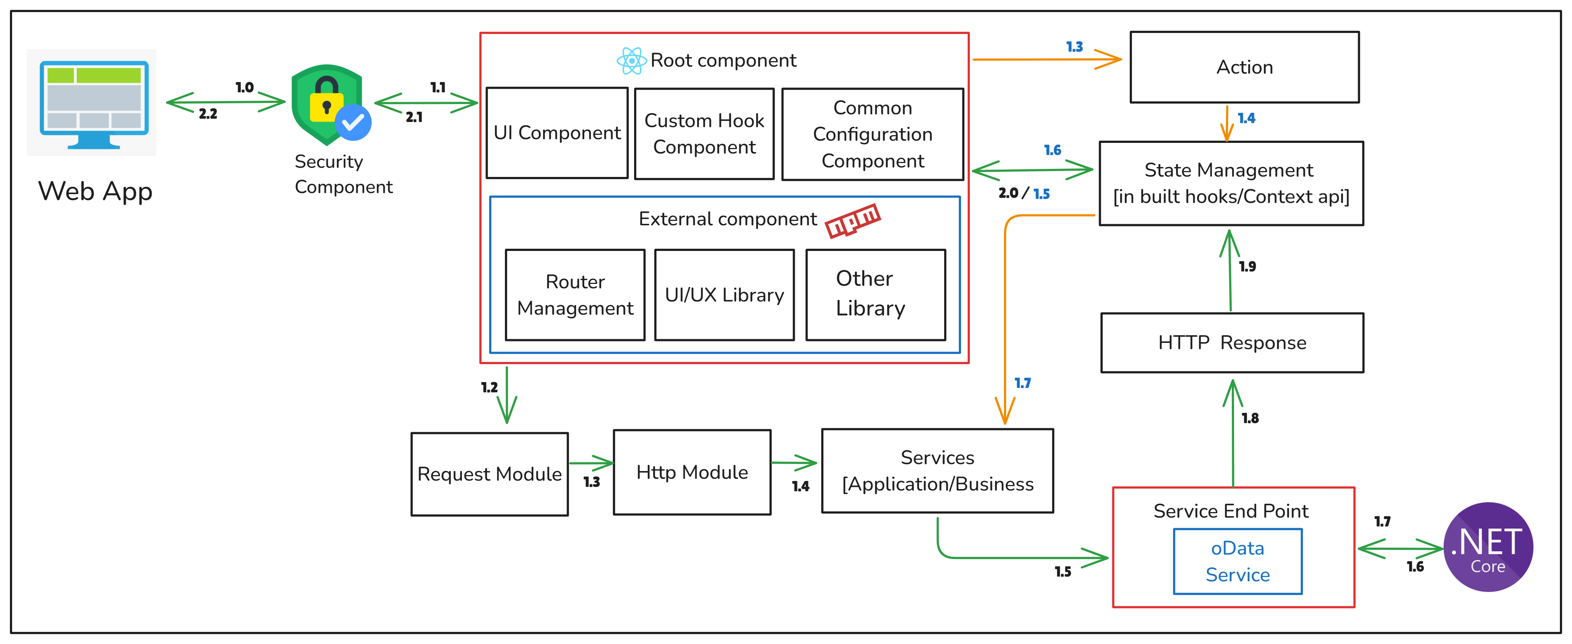

Admin (License Dashboard) Application

Users Page for Admin User

There has been provision in a system for Hanwha Team to create & manage the users. Super Admin has system level access and can manage each of sub users, roles & their permissions.

The system has a provision for super admin to create & update the sub admin user and its information who has access to it. This is very basic and essential information of sub users which is being utilized by Hanwha Vision project being consideration of their requirement.

Those are the internal users which will access the admin (License Dashboard) application to manage customers & their licenses based on given rights / access permissions.

Prototype:

<< Wire Frame >>

Business Rules:
- The super admin user will be able to create or update a new sub admin user from the admin (License Dashboard) application.
- Password length is 8 including 1 Minimum upper case, 1 Minimum lower Case, 1 Minimum numeric number, 1 Minimum special character except *.
- Email Address will be verified by sending email notification. While adding or updating the user information.

Data Dictionary:

Roles Page for Admin Users

There has been provision in the system for super admin to create & manage role of the sub user from the admin application.

Prototype:

<< Wire Frame >>

Business Rules:
- The super admin user will be able to create or update role(s) in the system from the admin application.
- The super admin user will be able to assign any specific role(s) to the specific sub admin user.
- The super admin user will be able to assign multiple roles to the specific user from the admin application.
- Admin has privileges to remove the role of any sub users too.
- The system will not allow super admin user to create duplicate role with named “Super Admin” because system will have only single super admin user. Who will have all rights to access the entire admin application.

Data Dictionary:

Role Assignments to The Admin User

There has been provision in the system for super admin to manage role assignments to the specific sub admin user from the admin application.

Once a role is defined, it is time to assign the responsibility to the respective users based on their designation and tasks.

This role assignment will be handled by super admin users or other users authorized by the admin. The system will allow access only according to the role assigned to the logged-in user.

Prototype:

<< Wire Frame >>

Business Rules:
- The super admin user can select and assign specific roles from a dropdown list to any sub-admin user.
- The super admin user can assign multiple roles to a sub-admin user, but this can only be done from the "Edit User" screen.
- The system will store the selected unique roleId(s) from the roleMaster table in the userMaster table. Refer to the highlighted row in GREEN in the image below for reference.

Data Dictionary:

Role Wise Permissions Management

The system provides a feature to assign permissions at the screen level with various types of access, such as add, update, delete, and view etc.

The super admin user can create roles with specific screen-level permissions and assign them to sub-admin users. When a user logs in, they will only have access to the functionalities permitted by their assigned role.

This screen will provide the ability to the super admin to update selected role wise permissions for the specific screen(s) or action(s).

Prototype:

<< Wire Frame >>

Business Rules:
- The super admin user will be able to select any specific role from the dropdown list & assign permissions on it.
- The super admin user will be able to assign specifics rights/permissions to the specific selected role.
- The system should allow access only on those screens / actions which are allowed against the assigned role for logged in sub user.
- The super admin user will have full access to the admin application.
- The super admin user can assign screen-level permissions and corresponding actions (e.g., add, update, delete, view) to roles. However, the Super Admin user cannot assign permissions to actions that are not applicable to specific screens (For example, Insert/Update/Delete rights are not applicable to screens like Profile or Change Password. Therefore, the system should restrict the Super Admin user from assigning these permissions to roles for such screens)
- The super admin user will be able to update roles at any point of time.
- The system will maintain the history of each change.

Data Dictionary:

Example of Screen Master table attached below to enhance more clarity on the backend implementation:
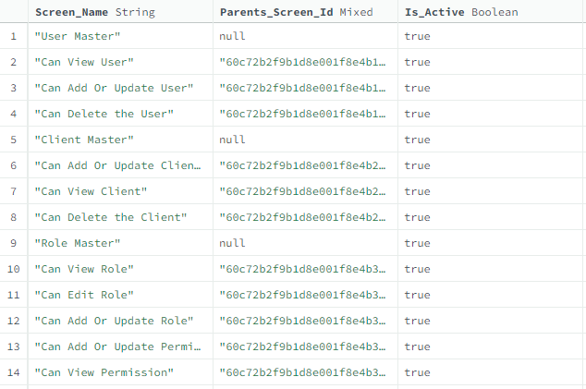
The above table contains a list of permissions that exist in the system, categorized by pages and their respective actions.

For example, the User Creation screen will have View, Add, Edit, and Update actions. Therefore, the following entries will exist in the table for the Users screen:

User Master
-> Can view user list
-> Can edit user details
-> Can add or update user details
-> Can delete user

Role & Screen Mappings: The table below provides information on screen-wise permissions assigned to specific roles:

Login Page for Admin User

There has been provision in the system for all admins to login into the admin (License Dashboard) application.

This page will validate the user’s credentials when any admin user tries to login into the system by entering their credentials.

Prototype:

<< Wire Frame >>

Business Rules:
- The Login screen will include a logo and text fields for entering the username or email address and password, along with a Login (Submit) button.
- Upon clicking the Login button, the application will validate the entered username or email address and password.
- If the credentials are successfully validated:
  - The application will check the user's authorizations and redirect them to the Customers & Licenses screen.
- If the entered credentials are invalid:
  - The system will display an appropriate error message on the login screen.
- If the user is marked as Inactive/Deleted in the system:
  - They will not be able to log in using their existing credentials.
  - In such cases, the user must contact the Respective Admin User of the Hanwha Vision Team for further assistance.
- The system will validate below highlighted fields while logging into the system.

Data Dictionary:

Forgot Password Page for Admin User

The admin (License Dashboard) application includes a provision that allows all admin users to reset their passwords if they forget it.

This screen is designed for registered admin users who have lost or forgotten their passwords. It enables them to regenerate a new password easily.

Prototype:

<< Wire Frame >>

Business Rules:
- The Forgot Password screen will include a logo and a text field for entering the registered email address.
- Upon clicking the Generate OTP button:
  - The admin user will receive an email containing an OTP to reset their password.
- After entering the OTP and clicking the Submit button:
  - The system will validate the OTP.
  - On successful OTP validation, the admin user will be redirected to the Reset Password screen.
- On the Reset Password screen:
  - The admin user will need to enter the New Password and Confirm Password fields.
  - Clicking the Submit button will update the user's password to the newly entered one in the system.
  - The admin user will also receive an email confirming that their password has been successfully changed.
- After changing the password:
  - The admin user will be redirected to the Login page, where they will be able to log in using the new password.

Data Dictionary:

The system will use the above table for OTP verification during the forgot password functionality and update the highlighted field in the userMaster table.

Menu Items for Admin User

The system provides a feature allowing all admins to log in to the admin (License Dashboard) application and access the following menus in the sidebar:

- Customers & Licenses
- Distributors
- Users
- User Management
  - Users
  - Roles
  - Permissions

Prototype:

<< Wire Frame >>

Business Rules:
- The logged-in admin user will be able to access the menus that are permitted based on the specific permissions assigned to the logged-in admin user.
- The system will hide any menus that are not allowed for the specific logged-in admin user according to their assigned permissions.

Data Dictionary:
- It is not required to manage any data dictionary for menu items, as it will be handled directly in the frontend code only.

My Profile Page for Admin User

The system provides a feature for all admins to log in to the admin (License Dashboard) application and access the My Profile page.

This page displays details specific to the logged-in admin user only.

The screen can be accessed by clicking on the My Profile link located at the top-right corner of the screen's top bar.

Prototype:

<< Wire Frame >>

Business Rules:
- The system will display information related to the logged-in user on this page. Which are enlisted below:
  - Profile Image
  - Full Name (First & Last Name)
  - Username
  - Email Address
  - Roles (which is assigned to logged-in user from the Users screen)
- This screen will allow logged-in users to view their details only.

Data Dictionary:
- This page will display registered information for the specific logged-in user from the userMaster table only.

Change Password Page

This screen allows admin users to reset their existing password.

The screen can be accessed by clicking on the Change Password link located at the top-right corner of the screen's top bar.

Prototype:

<< Wire Frame >>

Business Rules:
- All admin users will have access to this page.
- Admin users will be required to enter the following:
  - Old Password
  - New Password
  - Confirm Password
- Upon clicking the Submit button, the system will validate the entered old password:
  - If the old password is valid:
- The new password will be updated in the system.
- The logged-in user will be logged out from the admin application.
- The user must log in again using the newly created password.
  - If the old password is invalid:
- The system will display an appropriate error message to the user.
- Once the password has been successfully updated, the system will send an email to the user confirming the password change.

Distributors Page

The system provides a feature for admin users to create and manage distributors through the Admin (License Dashboard) application.

This page will be accessible exclusively to authorized admin users, with actions such as adding, editing, and deleting distributors displayed based on the permissions assigned to each admin user.

Prototype:

<< Wire Frame >>

Business Rules:
- Permitted users will be able to create and update distributor information within the application.
- The logged-in user must provide values for the following fields when creating or updating a distributor:
  - Distributor Name*
  - Country*
  - Email Address*
  - Description
- The “*” symbol indicates mandatory fields.
- The system will display a list of all created and updated distributors on this screen. Users will also be able to:
  - Adjust page size
  - Perform pagination
  - Search for specific records within the grid
- The system will not allow logged-in users to create duplicate distributors
- Users can delete a specific distributor by clicking the "Delete" icon. The system will prompt for confirmation before proceeding with the deletion.
- The system will offer filter options on specific columns using the MUI library, which is integrated into the entire web application. These filters will reset when the user reloads the page or navigates to another page.
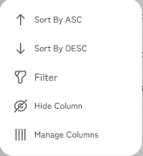

Customer & Licenses Management

The system includes a provision for the admin user(s) to create and manage customers through the admin application.

It will also provide an ability to manage customer wise their license details.

This page will be accessible only to authorized admin users, and actions such as adding, editing, and deleting customers will be displayed based on the admin user's assigned permissions.

Prototype:

<< Wire Frame >>

Business Rules:
- The admin user will be redirected to this page once they are successfully logged-in into the system.
- We can consider this page as a landing page after successfully logged in.
- The admin user will be able to create, update & delete customer(s) in the system from the admin application.
- The admin user will be able to.
- The super admin user will be able to assign multiple roles to the specific user from the admin application.
- Admin has privileges to remove the role of any sub users too.
- The system will not allow super admin user to create duplicate role with named “Super Admin” because system will have only single super admin user. Who will have all rights to access the entire admin application.

Data Dictionary:

---- end of document ----

